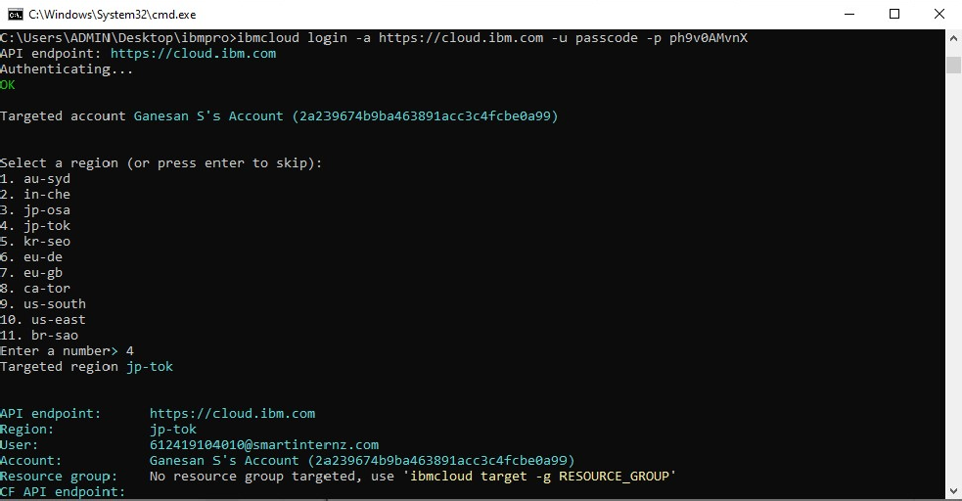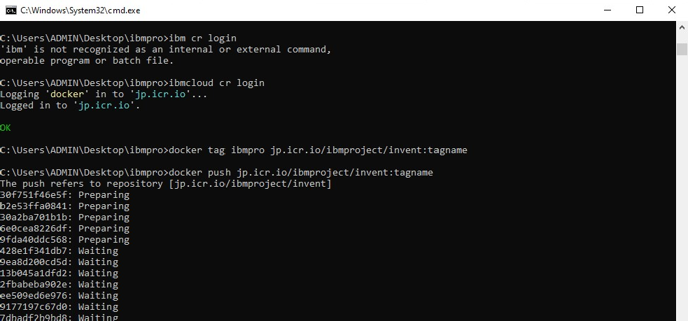

Upload Image To IBM Container Registry

|  |  |
| --- | --- |
| Date | 19/11/2022 |
| Team ID | PNT2022TMID41025 |
| Project Name | Inventory Management System for Retailers |

Uploading the image to ibm container registry:

